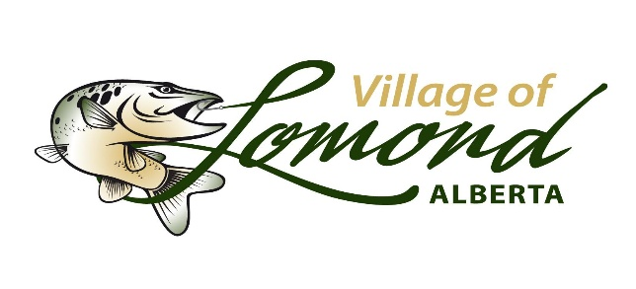

Fall Festival

Vendors Application
Name: _________________________________________________________________
Phone Number: _________________________________________________________
Email Address: __________________________________________________________
Business Name: __________________________________________________________
Description of Items Sold: _________________________________________________
__________________________________________________________________________
__________________________________________________________________________
Signature: ___________________________________
Date: ________________________________________
By signing this agreement, you agree to participate in the Village of Lomond’s Fall Festival on Oct 3rd, 2026, between 11am-3pm, at the Lomond school track field. There is no cost to participate. You agree to only sell the items listed above to avoid competition/conflict among other retailers. You assume all responsibility to manage your booth and remain on site until the completion of the event. You may only leave early if you sell ALL your goods. You must leave the booth in a cleanly state, remove all your items and dispose of trash appropriately. You assume all responsibility to replace any broken or damaged items provided such as but not limited to table/s, chair/s, tablecloths, etc. If damage occurs, the vendor is responsible for repair and/or replacement. This is an outdoor event.
Please sign and return to the Village Office in person, by email, or mail to:
Kathleen Stokes
Assistant Chief Administrative

Admin@villageoflomond.ca
PO Box 268, Lomond AB
T0L 1G0

